A REPORT ON

**AN INTELLIGENT HUMIDISTAT**

**BY**

[Priyansh Vyas](mailto:f20201388@goa.bits-pilani.ac.in) **2020A7PS1388G**

[Krishanu Shah](mailto:f20201728@goa.bits-pilani.ac.in) **2020A7PS1728G**

[Prateek Upadhya](mailto:f20200056@goa.bits-pilani.ac.in) **2020A7PS0056G**

[Ojas Kanth](mailto:f20201391@goa.bits-pilani.ac.in) **2020A7PS1391G**

[Piyush Mohite](mailto:f20200114@goa.bits-pilani.ac.in) **2020A7PS0114G**

[Omkar Nabar](mailto:f20200119@goa.bits-pilani.ac.in) **2020A7PS0119G**

In partial fulfilment of the requirements of the course

**CS F241: Microprocessors, Programming & Interfacing (MPI)**

Under the guidance of

[K.R. Anupama](mailto:anupkr@goa.bits-pilani.ac.in)

**Department of EEE&I**



## 

## **LIST OF CONTENTS**

LIST OF CONTENTS **2**

ACKNOWLEDGEMENT **3**

LIST OF COMPONENTS USED **4**

PROBLEM STATEMENT **6**

ASSUMPTIONS **6**

JUSTIFICATIONS **7**

ADDRESS MAPPING **7**

MEMORY MAPPING 7

I/O MAPPING 8

MEMORY AND ADDRESS MAP 9

SOFTWARE FLOW-CHART **10**

LIST OF ATTACHMENTS **11**

REFERENCES **13**

## 

## **ACKNOWLEDGEMENT**

The successful completion of this report required a lot of guidance and support that we received throughout this project. We would like to extend our deepest gratitude to the Instructor-in-Charge (IC) of this course, Prof. K.R. Anupama for giving us this opportunity to work on such an interesting assignment and for clearing our doubts regarding the same.

We would also like to thank our seniors for guiding us all along till the completion of this report.

## 

## 

## 

## **LIST OF COMPONENTS USED**

| **Model Number** | **Component** | **Quantity** | **Specifications** | **Purpose** |
| --- | --- | --- | --- | --- |
| **8086** | Microprocessor | 1 | * Size: 16-bit * Memory: 1MB | Central Processing unit for the design. |
| **LM020L** | LCD Alphanumeric 16×1 | 1 | * Display: 16 characters in 1 line * Power Supply for LCD Drive * Operating temperature:   0 - 50 °C   * Power supply current   (Vdd = 5V): 1 - 3 mA | Display temperature and humidity readings. |
| **WE700** | Global Water WE700/WQ101 Temperature Sensor | 1 | * Output: 4-20mA * Range: -50 to +50° C * Resolution: 2° F or 1° C * Operating Voltage: 10-36VDC * Warm-Up Time: 5 seconds * Operating Temperature:   -50 to +100°C | Used to measure the outside temperature and provide temperature readings |
| **WE600** | Global Water WE600 Humidity Sensor | 1 | * 4-20 mA output * Accuracy: ±2% RH * Operating Voltage: 10-36V DC * Temp: -40 to 55°C | Sense, measure and report the relative humidity (**RH**) of air. |
| **8255** | PPI | 2 | * Programmable Peripheral Interface. | Provides I/O ports for other devices. |
| **6116** | SRAM - 2K | 2 | * Static Random Access Memory. | Used to store temporary data (such as temperature values, humidity values, stack, etc.). Contains Data and Stack Segment. |
| **2732** | EPROM - 4K | 2 | * Erasable Read-Only Programmable Memory | Code resides here. |
| **74LS373** | Octal Latch | 3 | * Supply voltage =4.75-5.25 V * Operating Ambient Temperature Range: 0-70°C | To latch address bus |
| **74LS245** | 8-Bit Buffer | 4 | * Supply voltage = 4.75-5.25 V * Free Air Operating Temperature: 0-70°C | To buffer data bus (bi-directional) |
| **74LS138** | 2 | 3x8 Decoder |  | Used for selecting signals |
| **74LS244** | 1 | Unidirectional buffer |  | Buffering the control lines |
| **Logic Gates** | Multiple | OR, NOT, NOR logic Gates |  | Used for building decoding logic for memory interfacing and I/O interfacing. |

## 

## **PROBLEM STATEMENT**

A humidistat is supposed to be reset according to the outside temperature- as the outside temperature falls, the humidity level inside the house should be lower. This project aims to develop a humidistat that senses the outside temperature and adjusts the humidity accordingly. Two sensors are required: outside temperature and inside moisture. Output is provided via a simple relay with the humidifier (presumably on the furnace) being on or off. Also, readings from the humidity and temperature sensors must be displayed on an LCD. The entire system can be turned on or off using a single switch.

## **ASSUMPTIONS**

* ALP is stored in the ROM in executable format.
* The outside temperature is between 10° C and 40° C.

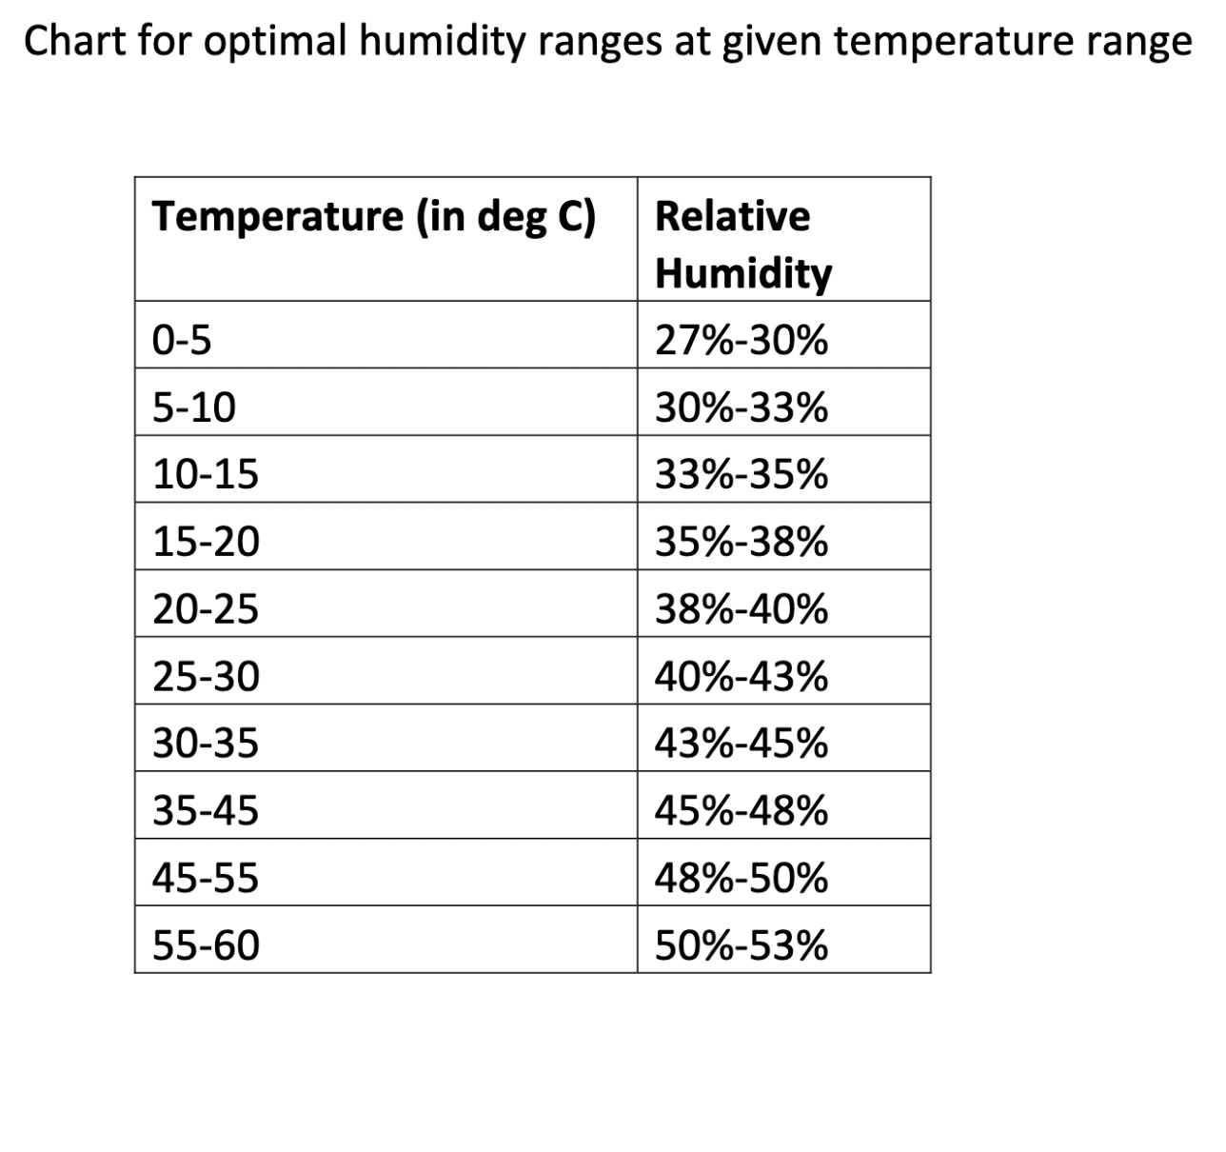

* When the humidifier is switched on, it decreases the humidity.
* The humidifier circuit is represented in the design via an LED, which turns on when the LED glows, and consequently, the humidifier turns off when the LED stops glowing.

## **JUSTIFICATIONS**

* Temperature and relative humidity (RH) are already stored in the DS, and a one-degree change in temperature corresponds to one unit change in RH.

## **ADDRESS MAPPING**

### **MEMORY MAPPING**

The system uses 8kb of ROM and 4kb of RAM.

Both consist of 2 chips of 4KB and 2KB size, respectively. They are organised into odd and even banks to facilitate both byte and word size data transfers.

**Random Access Memory (6116):**

***Even Bank:***

• *Starting Address:* 08000H

• *Ending Address*: 08FFEH

***Odd Bank:***

• *Starting Address:* 08001H

• *Ending Address*: 08FFFH

**Read-Only Memory (2732):**

• *Starting Address*: 00000H

• *Ending Address*: 01FFFH

The assembly code resides in the ROM and begins at address 00000H.

The address loaded as soon as the system is switched on is FFFF0H.

### **I/O MAPPING**

The input and output devices such as temperature & humidity sensor and LCD are connected using 8255. Both 8255 are used in Input-Output mode.

Pinout for **8255 (A)**

Control Word: 10000000b

Port A is used to generate the control signal of LCD

Port B is used to give input to the LCD

PC7 is used to turn on the humidifier.

| **PORT TYPE** | **PORT ADDRESS** | **TYPE** |
| --- | --- | --- |
| A | 00H | Output |
| B | 02H | Output |
| C (Lower) | 04H | Output |
| C (Upper) | 04H | Output |
| Control Register | 06H |  |

Pinout for **8255 (B)**

Control Word: 10011010b

Port A is used to take the digital output from ADC

PC0 – PC3 are used to give control input to ADC

PC5 is used to receive the signal of EOC.

| **PORT TYPE** | **PORT ADDRESS** | **TYPE** |
| --- | --- | --- |
| A | 10H | Input |
| B | 12H | Input |
| C (Lower) | 14H | Output |
| C (Upper) | 14H | Input |
| Control Register | 16H |  |

### **MEMORY AND ADDRESS MAPS**

| **CHIP** | **A19** | **A18** | **A17** | **A16** | **A15** | **A14** | **A13** | **A12** | **A11** | **A10** | **A9** | **A8** | **A7** | **A6** | **A5** | **A4** | **A3** | **A2** | **A1** | **A0** |
| --- | --- | --- | --- | --- | --- | --- | --- | --- | --- | --- | --- | --- | --- | --- | --- | --- | --- | --- | --- | --- |
| **EPROM 2732** |  |  |  |  |  |  |  |  |  |  |  |  |  |  |  |  |  |  |  |  |
| **FROM 000000h** | **0** | **0** | **0** | **0** | **0** | **0** | **0** | **0** | **0** | **0** | **0** | **0** | **0** | **0** | **0** | **0** | **0** | **0** | **0** | **0** |
| **TO**  **01FFFh** | **0** | **0** | **0** | **0** | **0** | **0** | **0** | **1** | **1** | **1** | **1** | **1** | **1** | **1** | **1** | **1** | **1** | **1** | **1** | **1** |
| **SRAM 6116** |  |  |  |  |  |  |  |  |  |  |  |  |  |  |  |  |  |  |  |  |
| **FROM**  **08000h** | **0** | **0** | **0** | **0** | **1** | **0** | **0** | **0** | **0** | **0** | **0** | **0** | **0** | **0** | **0** | **0** | **0** | **0** | **0** | **0** |
| **TO**  **08FFFh** | **0** | **0** | **0** | **0** | **1** | **0** | **0** | **0** | **1** | **1** | **1** | **1** | **1** | **1** | **1** | **1** | **1** | **1** | **1** | **1** |

## **SOFTWARE FLOW-CHART**

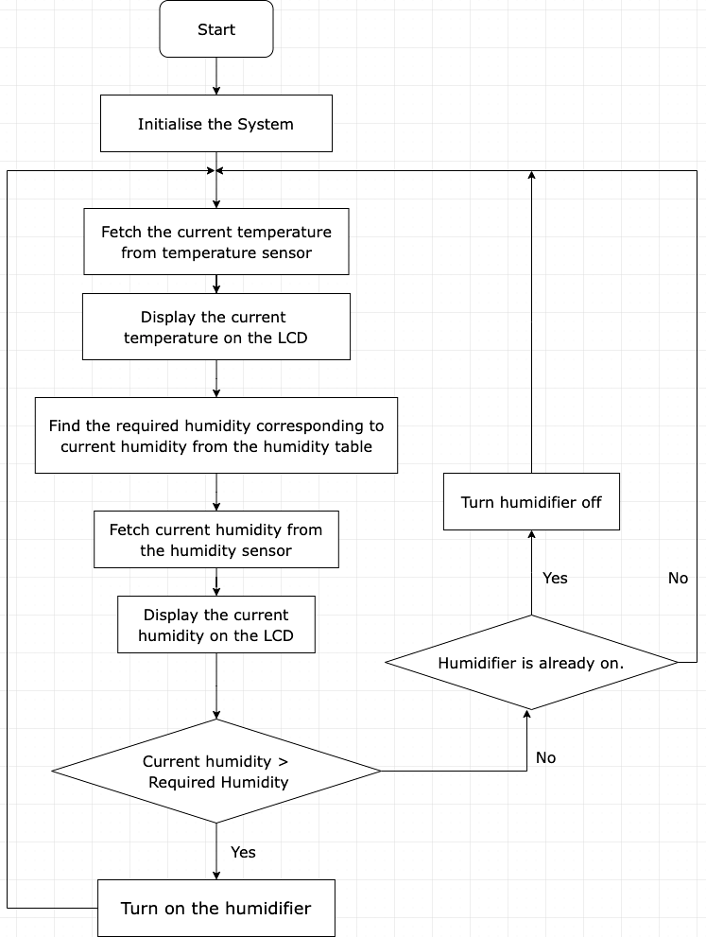

## **LIST OF ATTACHMENTS**

**Temperature and Humidity sensors**

## 

**LCD Display Specifications**

## 

## 

## 

## **REFERENCES**

1. <https://www.ysi.com/we600>
2. <https://www.digchip.com/datasheets/parts/datasheet/000/LM020L-pdf.php>